# Specifications

**DP-F850 DP-F550**

|  |  |  |
| --- | --- | --- |
| **Model Type** | Floor standing | Floor standing |
| **Master Making Method** | Thermal digital master making | Thermal digital master making |
| **Master making interval** | 18 seconds (A4) | 18 seconds (A4) |
| **Resolution** | Scan: 600 dpi x 600 dpi  Print: 600 dpi x 600 pdi  Master punch density: 600 dpi x 600 dpi* | Scan: 300 dpi x 600 dpi  Print: 300 dpi x 600 dpi  Master punch density: 600 dpi x 600 dpi |
| **Master Feeding** | Automatic | Automatic |
| **Scanning Method** | Flat bed scanner | Flat bed scanner |
| **ADF Capacity** | Optional, 100 sheets (64gsm) | Optional, 100 sheets (64gsm) |
| **Printing Method** | Stencil print | Stencil print |
| **Top Print Speed** | 150 prints per minute (A4, B4, Letter) | 150 prints per minute (A4, B4, Letter) |
| **Max Print Area** | 290 x 423 mm | 290 x 423 mm |
| **Document size** | Max: 297 mm x 432 mm Min: 100 mm x 148 mm *1 | Max: 297 mm x 432 mm Min: 100 mm x 148 mm *1 |
| **Print Paper Size** | Max: 320 mm x 450 mm  Min: 100 mm x 150 mm | Max: 320 mm x 450 mm  Min: 100 mm x 150 mm |
| **Sheet Pile** | 1200 (64gsm) | 1200 (64gsm) |
| **Feeder Stack Height** | 140 mm | 140 mm |
| **Stacker Stack Height** | 150 mm | 150 mm |
| **Paper Weight** | 45 – 210gsm | 45 – 210gsm |
| **Ink Volume** | 1000 cc | 1000 cc |
| **Power Supply** | 100-240V, 50/60 Hz, 220 W, 2.4-1.0A | 100-240V, 50/60 Hz, 220 W, 2.4-1.0A |
| **Reduction/Enlargement** | 61,70, 81, 86, 115, 122, 141,163 % *2 | 61,70, 81, 86, 115, 122, 141,163 % *2 |
| **Zoom** | 50-500% | 50-500% |
| **Image Modes** | Text, Photo, Text/Photo, Pencil, Screen | Text, Photo, Text/Photo, Pencil, Screen |
| **Multiple Printing** | 2 in 1 | 2 in 1 |
| **Multiple Exposure** | 2, 4, 8 & 16-up  Custom: Max 25-up | 2, 4, 8 & 16-up  Custom: Max 25-up |
| **Confidential Safeguard** | Yes | Yes |
| **Ink Supply Method** | Automatic control | Automatic control |
| **Colour Print** | Drum unit change | Drum unit change |
| **Envelope Feeder Kit** | Optional | Optional |
| **Dimensions (W x D x H)** | 1401 mm(W) x 688 mm(D) x 1080 mm(H) WITH ADF: 1401 mm(W) x 688 mm (D) x 1222 mm(H) | 1401 mm(W) x 688 mm(D) x 1080 mm(H) WITH ADF: 1401 mm(W) x 688 mm (D) x 1222 mm(H) |
| **Net Weight** | 102kg | 102kg |
| *1 With optional ADF  *2 for A3 size |  |  |

**DP-F550 & DP-F850**



ECO AND USER FRIENDLY, ECONOMICAL DIGITAL DUPLICATORS

## Up to 150 prints per minute 600 x 600 dpi resolution

**1500 sheet capacity User ID Manager USB connectivity**

**Optional ADF available**

**Duplo International Limited** Automated Precision House Hamm Moor Lane Addlestone

Surrey KT15 2SD

Tel +44(0) 1932 263 900 - Fax +44(0) 1932 263 901

[info@duplointernational.com](mailto:info@duplointernational.com) [www.duplointernational.com](http://www.duplointernational.com/)

Duplo is a trade mark of the of the Duplo Corporation.

Duplo has a policy of continuous improvement

and reserves the right to amend the above specification without prior notice

Production rates are based on optimal operating conditions and may vary depending on stock and environmental conditions.

Ref: DPF/11/14

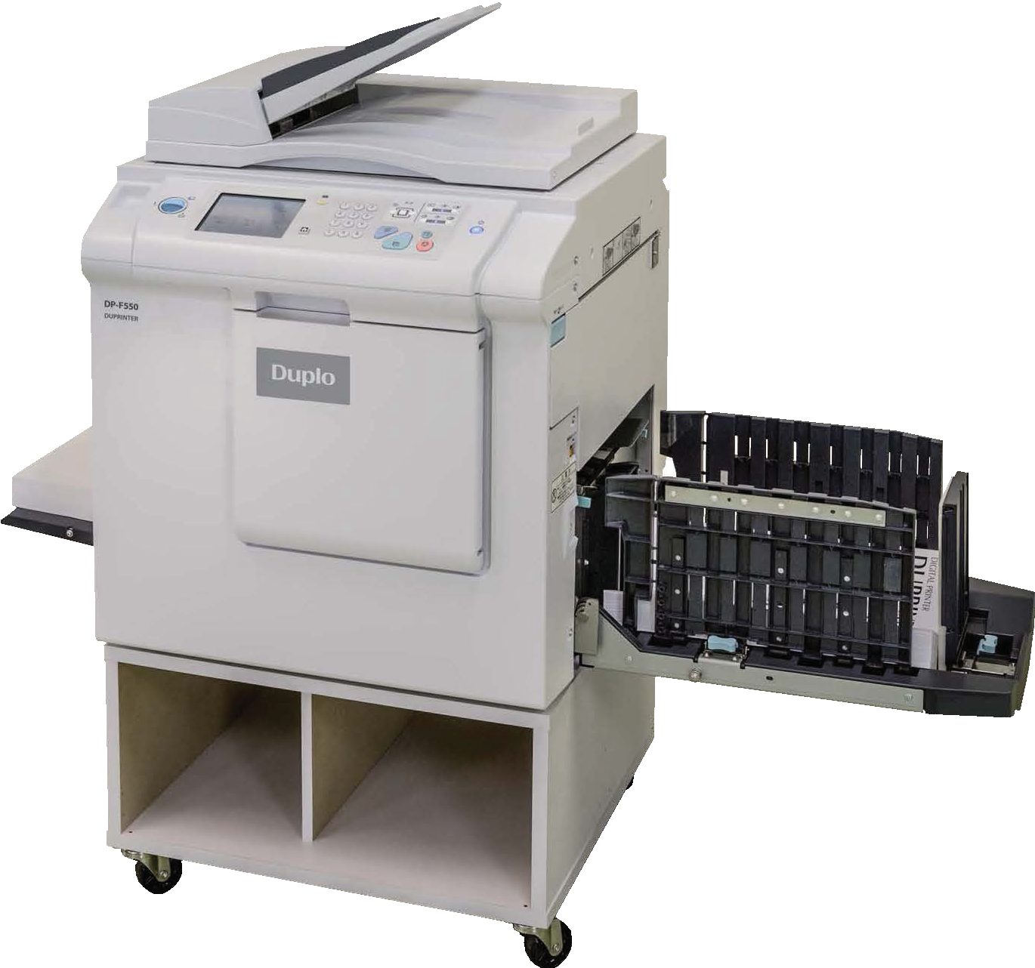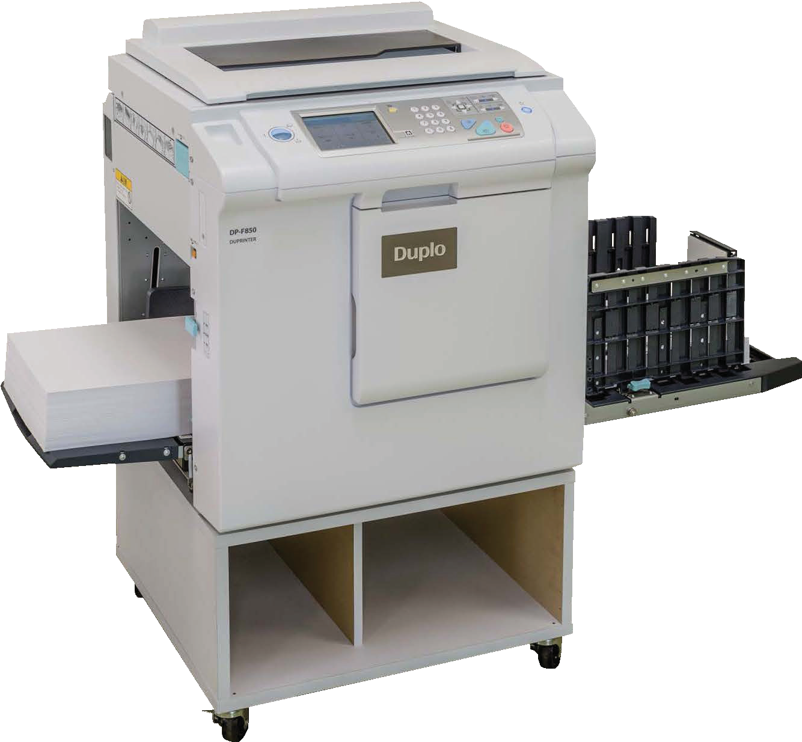

DJ410-DP-F Series Brochure 11-14.indd 1-2 02/12/14 13:38

**The DP-F series models are high productivity digital duplicators with reliable and user friendly operations which produce quality professional prints in a compact design. The DP-F range has a Full Colour Touch Panel as well as some new keys adopted on the control panel which makes the operation even more user friendly.**

## High Quality Print

The DP-F series can scan and print at a resolution of 600 x 600 dpi on the

DP-F850 and 300 x 600 dpi on the DP-F550, reproducing originals to exceptionally high standards. The

operator can scan via the flatbed scanner or via the optional ADF. Alternatively you can print direct from a PC, Mac or via a network with the USB 2.0 connectivity.

## Feeding Mechanism

The feeding system is the heart of the DP-F series: It can reliably and



consistently feed a wide range of stocks from carbonless to cards as well as postcards up to 297 x 432mm. It can accommodate thicknesses from 45

to 210gsm. Superb paper handling is achieved through Duplo’s tried and tested automatic lift-up and paper delivery, the unique triple feed wheels for accurate feeding and the fan and belt paper ejection system for reliable delivery.

## Productivity

The DP-F series can produce upto 150 prints per minute without compromising the quality of printing. The master making process of the DP-F850 and

DP-F550 is 18 seconds. To ensure maximum productivity and less user intervention the DP-F series is equipped with the feeding and stacking capacity of 1500 sheets (64gsm).

## Multiple Exposure

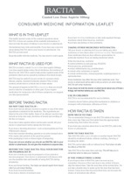Increase productivity on the DP-F series by using the multiple exposure function. It is equipped with a 2, 4, 8 and 16-up function.

|  |  |
| --- | --- |
|  |  |
|  |  |



## User ID Manager

The User ID Manager is an excellent security feature. It is also a great way to control spending within a company.

## Environmentally friendly

 Like all the Duprinters, the DP-F series

is extremely environmentally friendly. It

uses water based inks and produces no ozone or emissions.

## Colour Printing



Create added value to your documents by adding a spot colour. A variety of coloured inks are available on the whole Duprinter range. A pantone colour service is also provided should a specific colour be required.

## Options



Optional envelope feeder for reliability, eﬀective and fast feeding of all sizes of envelope.

## 3 Image Modes

The DP-F series is equipped with 3 image modes. As soon as an image mode

has been selected, the Duprinter will automatically adjust its setting to ensure the print quality is at its best

## Reduction and Enlargement

Document size can be enlarged and reduced on the DP-F series. Reduction: 61%,70%, 81% and 86%, Enlargement:



**Printing Process**

Scan document via ADF/Flatbed Scanner Send document via Computer/USB

**Drum**

**Paper**

**Exit tray**

**Delivery Tray**

**Impression Roller**

Straight Paper Path = Faster Print & Fewer Jams

115%, 122% , 141% and 163%.

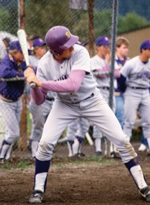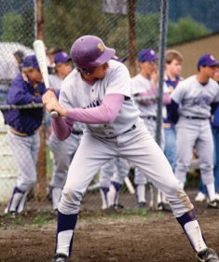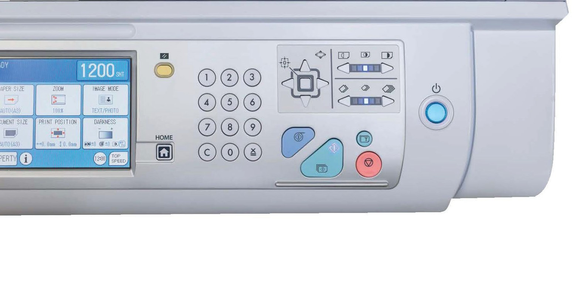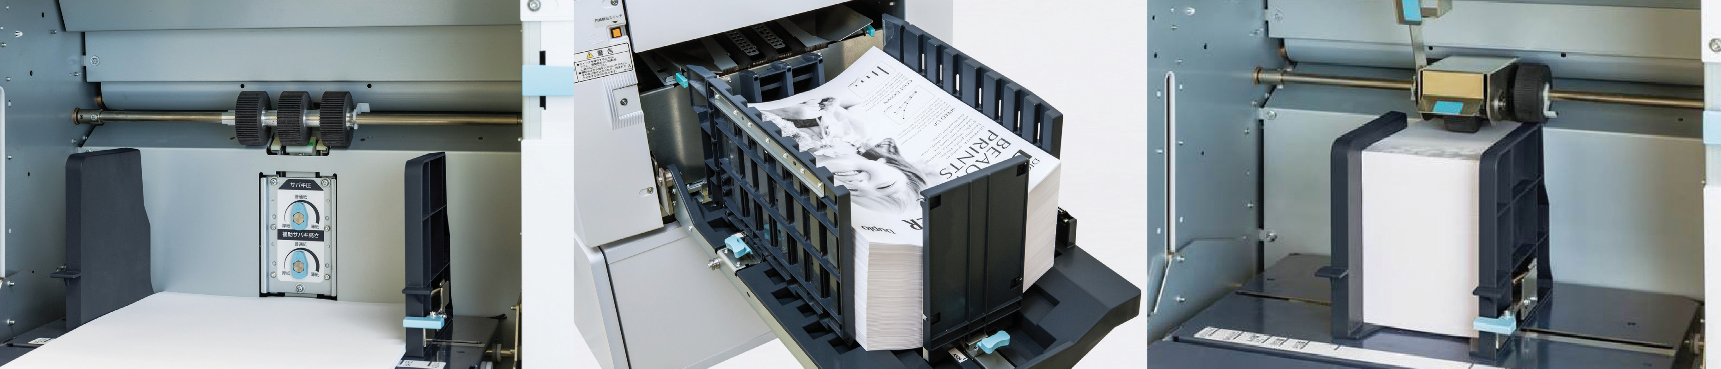

Control panel Feed wheels Stacker Envelope feeder

DJ410-DP-F Series Brochure 11-14.indd 3-4 02/12/14 13:38